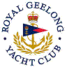 | Royal Geelong Yacht Club Inc.  Est 1859
Trophy Deed of Gift.

Trophy: | Murray M^{c}Allister Perpetual Trophy
Presented by: | Murray M^{c}Allister
Date: | 1972
For: | Open Handicap Race Geelong => Queenscliff
Remarks / Revisions | Stern-chaser
Click here to View Recipients

